|  |  |  |  |
| --- | --- | --- | --- |
| **Mobile Applications and Web Development -IS4904(Practical)** | | | |
| **Student Name:** | **Student ID:** | | **Section:** |
| **Assignment (Classes and constructors)** | | | |
| **Date: 19 March 2024** | | **Max Points:** | |

**Problem Statement: Learning** **Management System**

You are tasked with developing an Learning Management System (LMS) using Dart programming language. The LMS should allow users to add, view, update, and delete course records. Each course record should contain the following information:

* Course ID (unique identifier)
* Course Name
* Course Department
* Reference
* Coordinator

Write your program using Dart class notion. Your program should provide methods to perform the following operations:

1. Add Courses: the Courses 's information (Courses ID, Courses name, Courses department etc) will be set to the course objects in the system (use a set method).
2. Use an overridden toString method to print Course data.

**Notes:**

1. Pay close attention to class and variable initialization, ensuring that all variables are properly initialized and utilized throughout the program.
2. Use the constructors to create 4 objects (in the main function).
   1. The system can create empty object using default constructor.
   2. Also can create objects with default values (use any suitable constructors).
3. Use the objects to add and display courses details.

**Submission Guidelines:**

* Include comments and documentation to explain the purpose of each class, method, and variable in your program.
* Test your program thoroughly to ensure that it functions correctly and produces the expected output under various scenarios.
* Take screen pictures and place them in your answer file.
* Submit your Dart program files along with any necessary instructions or documentation.Top of Form

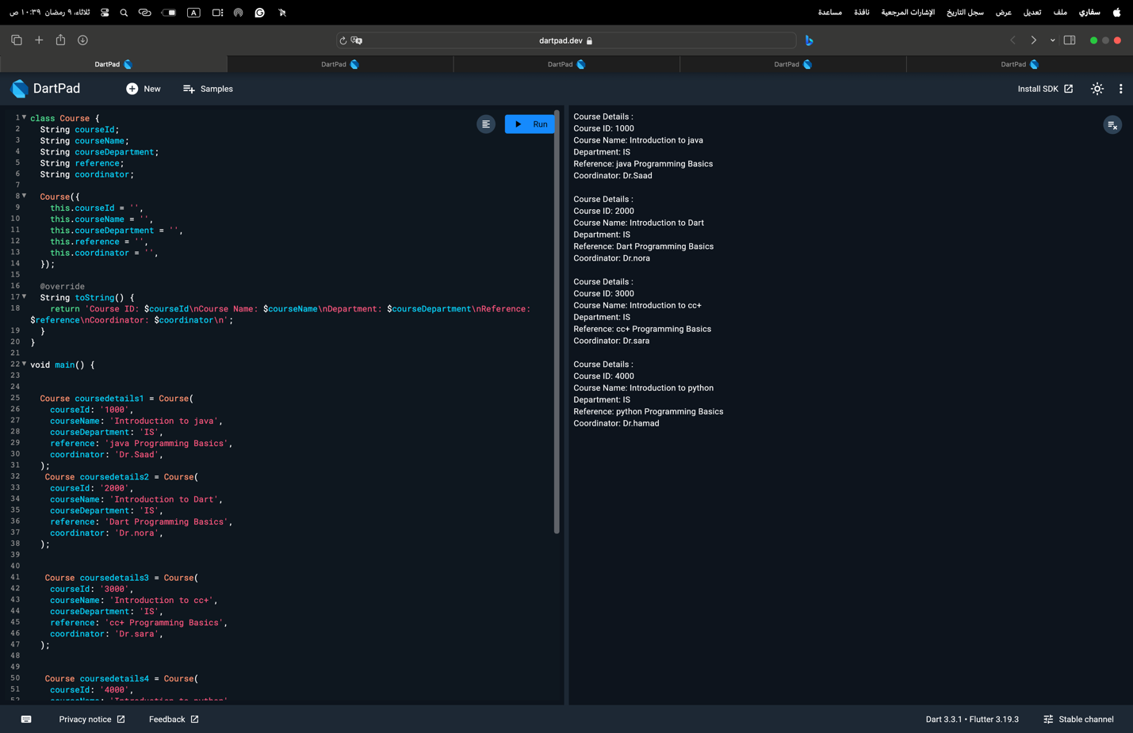

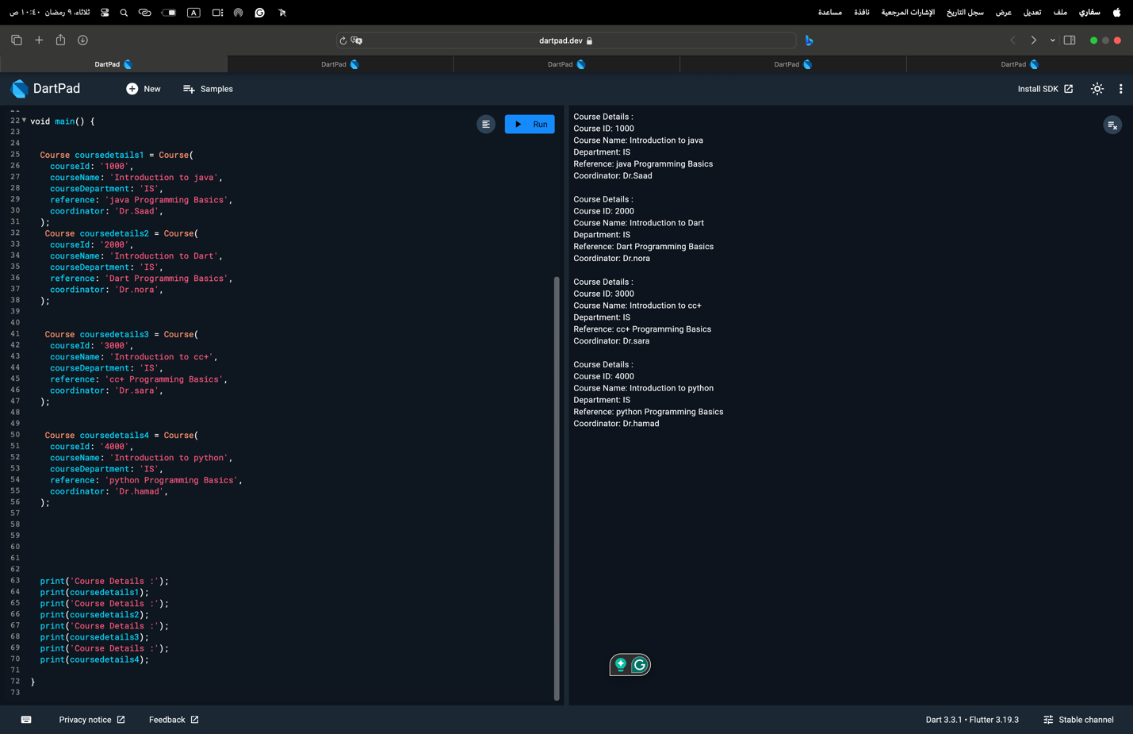

1. **Java Course**: Teaches fundamentals of Java programming including object-oriented concepts and application development.

2. **Dart Course**: Covers Dart language basics and advanced features for web and mobile app development.

3. **C++ Course**: Focuses on C++ programming essentials, emphasizing memory management, object-oriented programming, and application development.

4. **Python Course**: Introduces Python programming for various applications such as web development, data analysis, and machine learning, emphasizing simplicity and versatility.